<https://dev.mysql.com/downloads/mysql/>

Go to the [MySQL website](http://dev.mysql.com/downloads/mysql/) and download the latest version of MySQL for MacOS.

Click the Download button next to the version you choose.

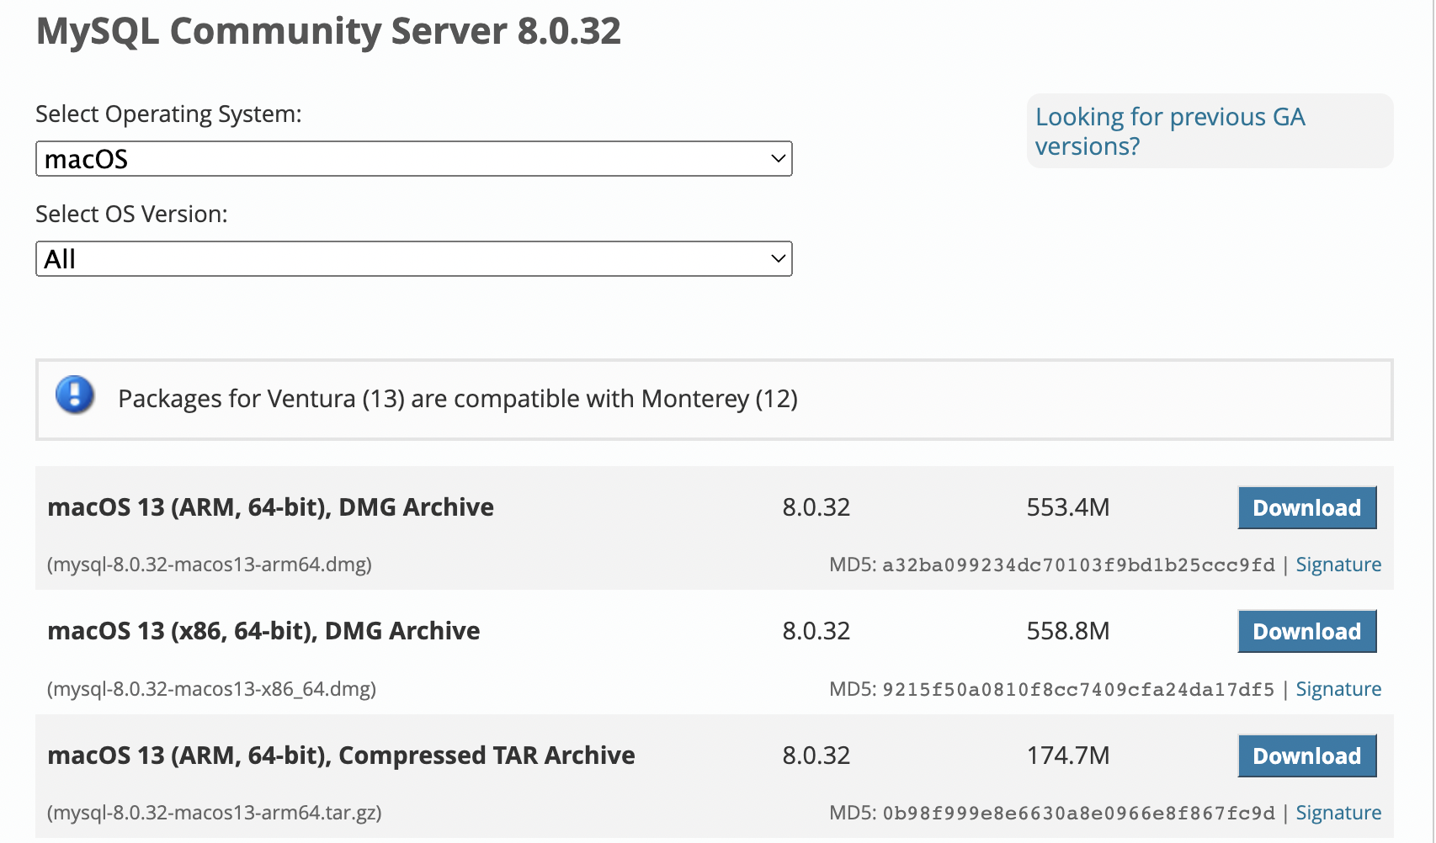

You are prompted to sign up for an Oracle Web Account, but unless you want one, click **No thanks, just start my download**.

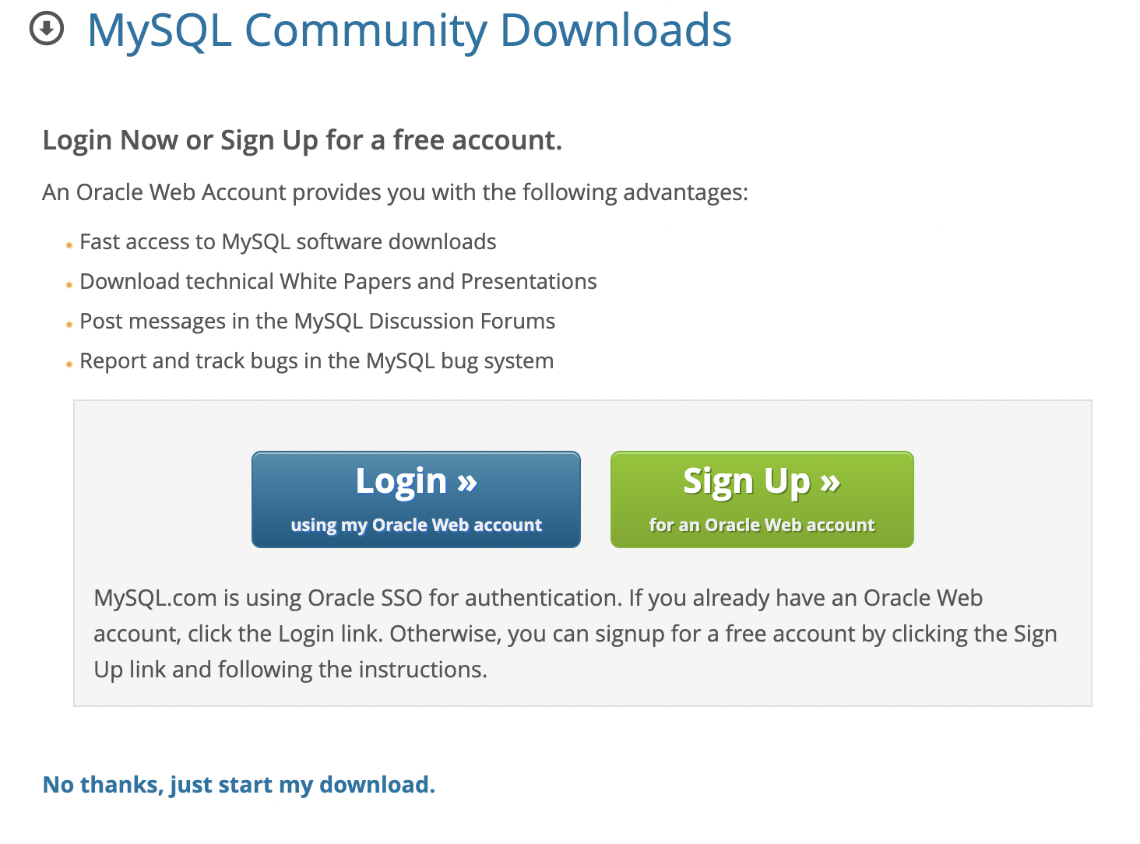

Click on the .dmg file that is downloaded

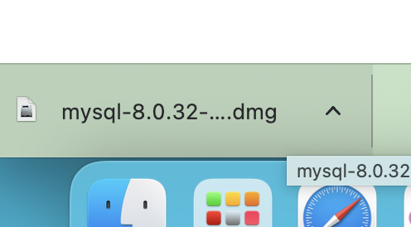

Double-click the icon for the **MySQL package installer**.

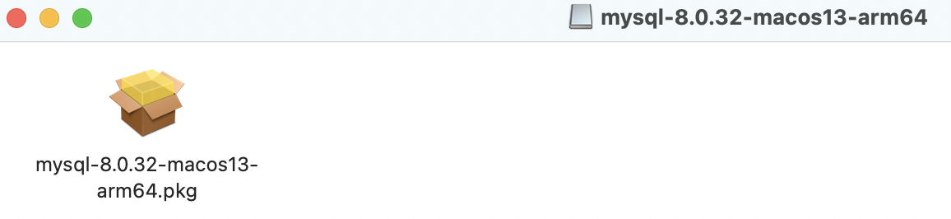

Click on “**Continue**” to begin the installation.

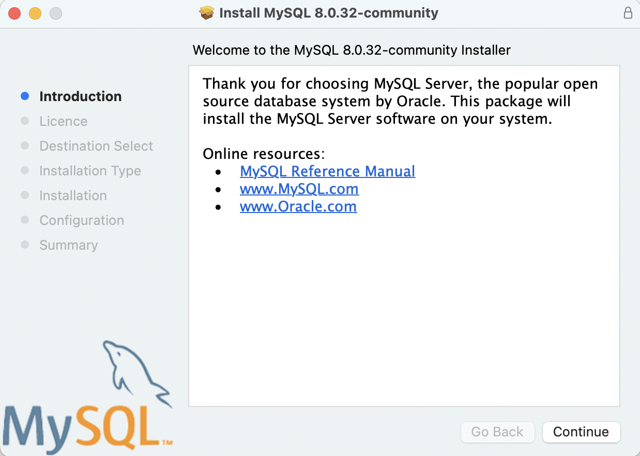

Click on “**Continue**” again

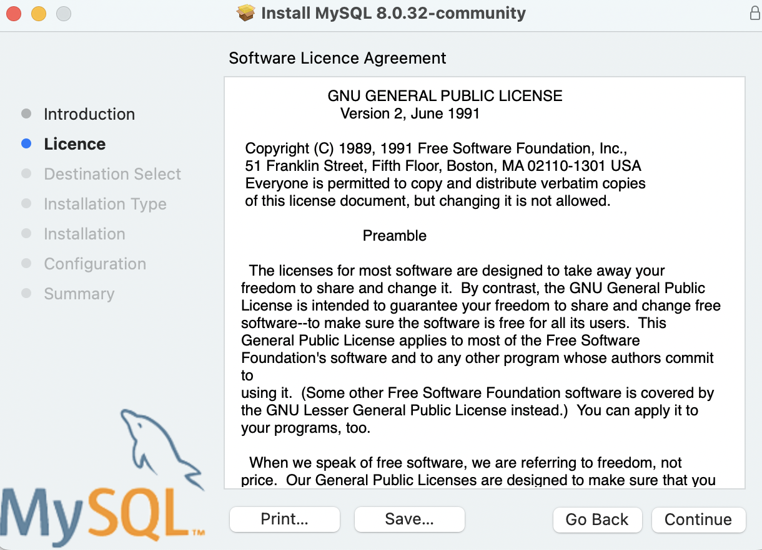

Click on **Agree**

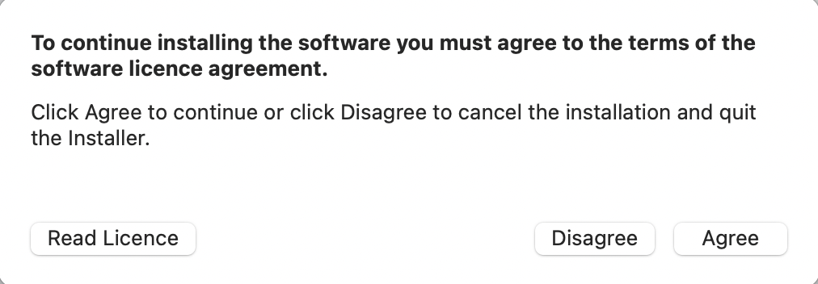

Click on **Install**

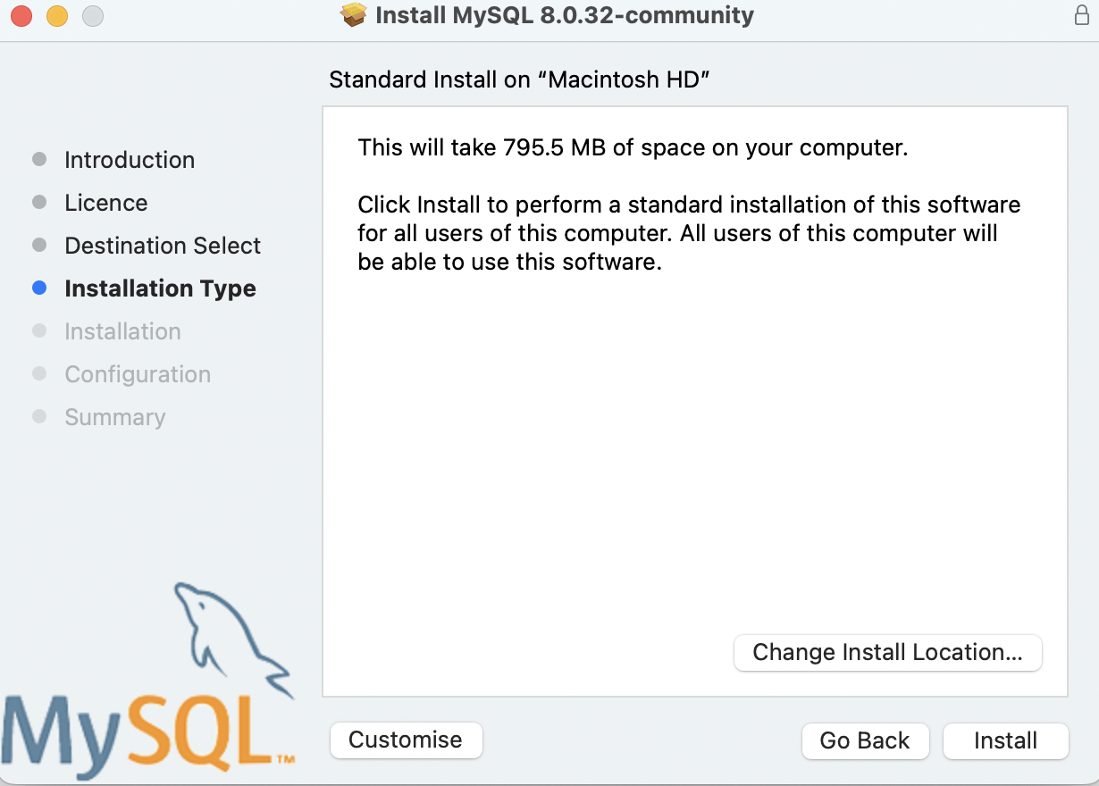

Click on “**Next**”, set up a Password and Click on “Finish”

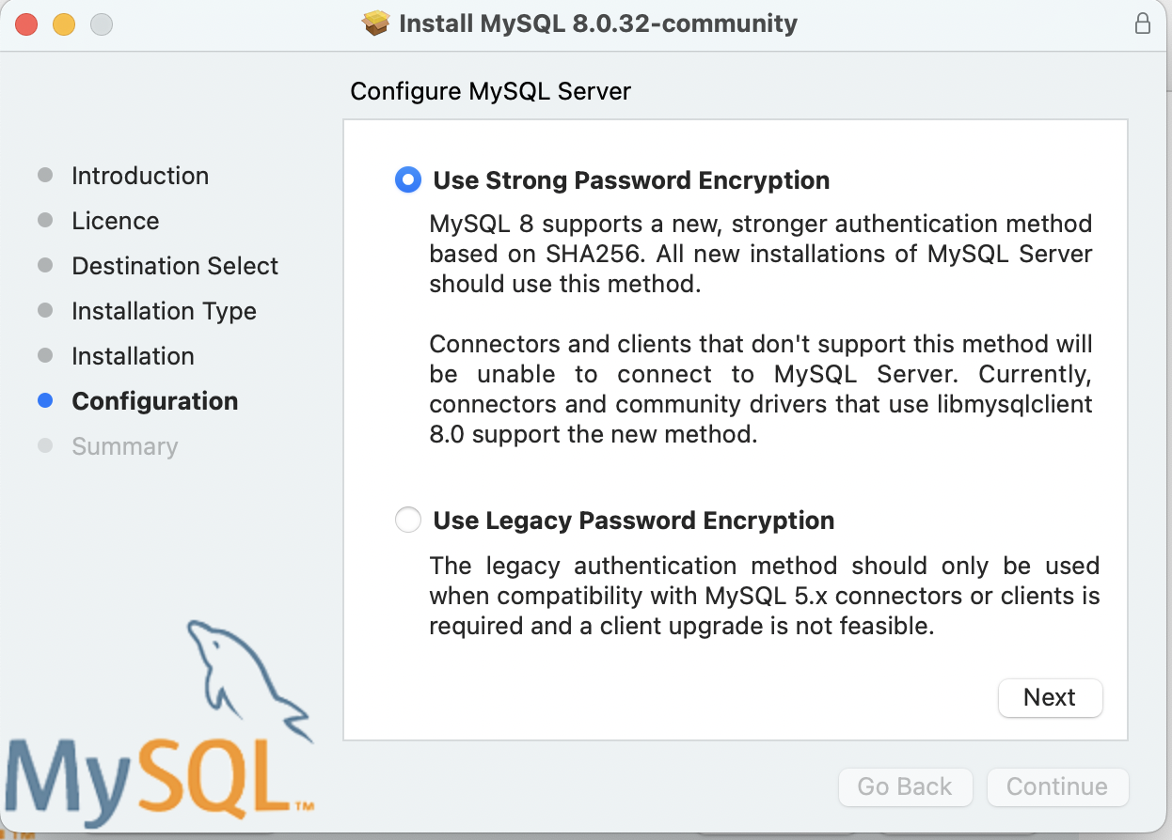

Set up a password and click on “**Finish**”

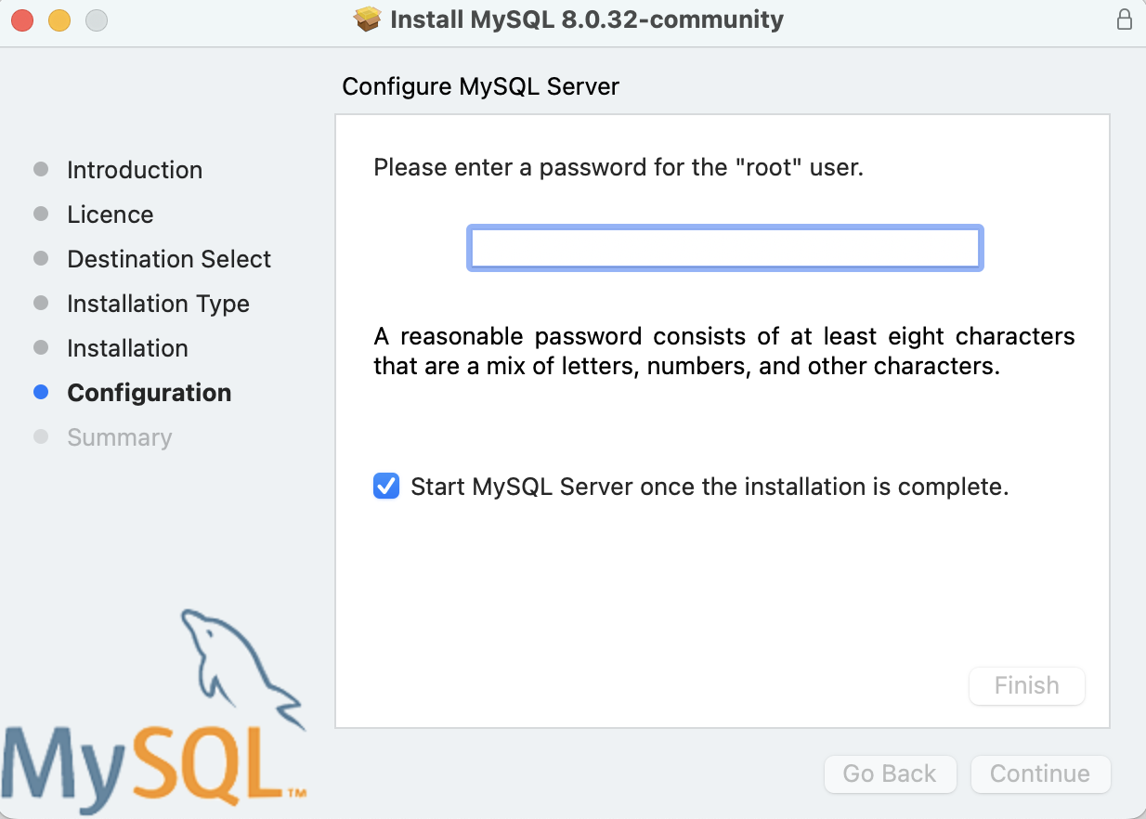

Click on “**Close**”

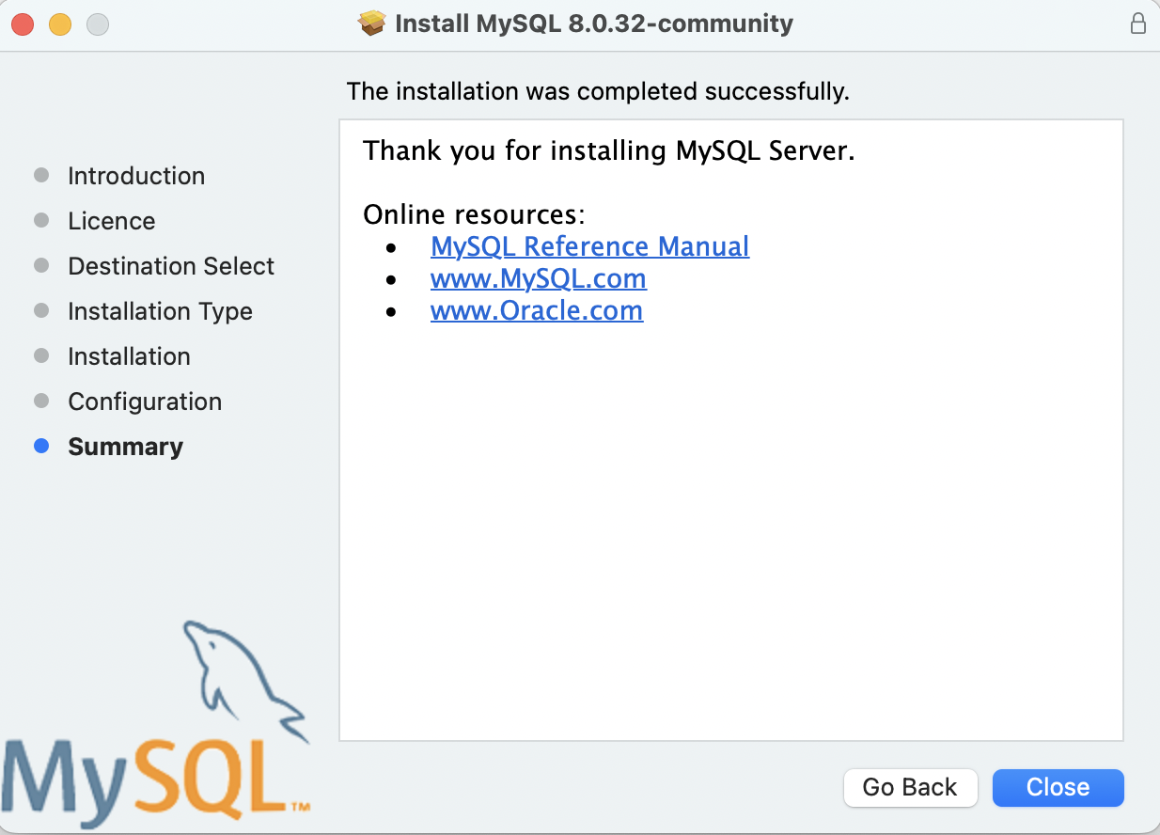

To Open MySQL on MAC –

Open System Preferences, select the MySQL icon

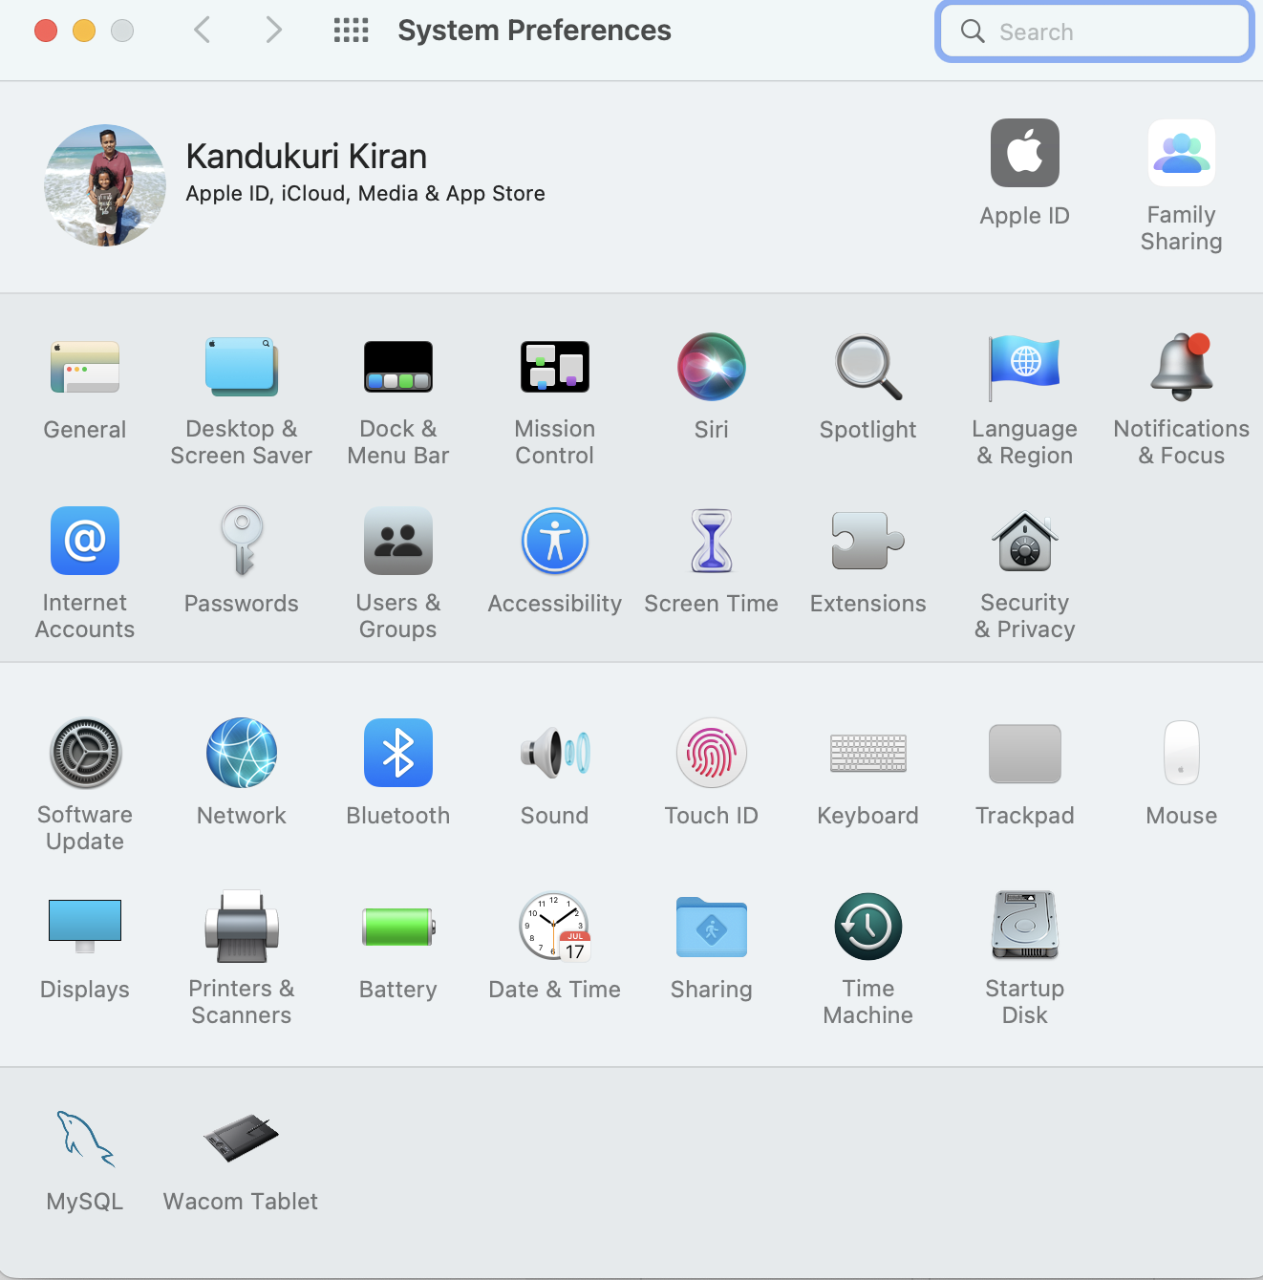

Click on the “**Initialize**” Button, then on the next screen, enter the password and click on “**OK**”

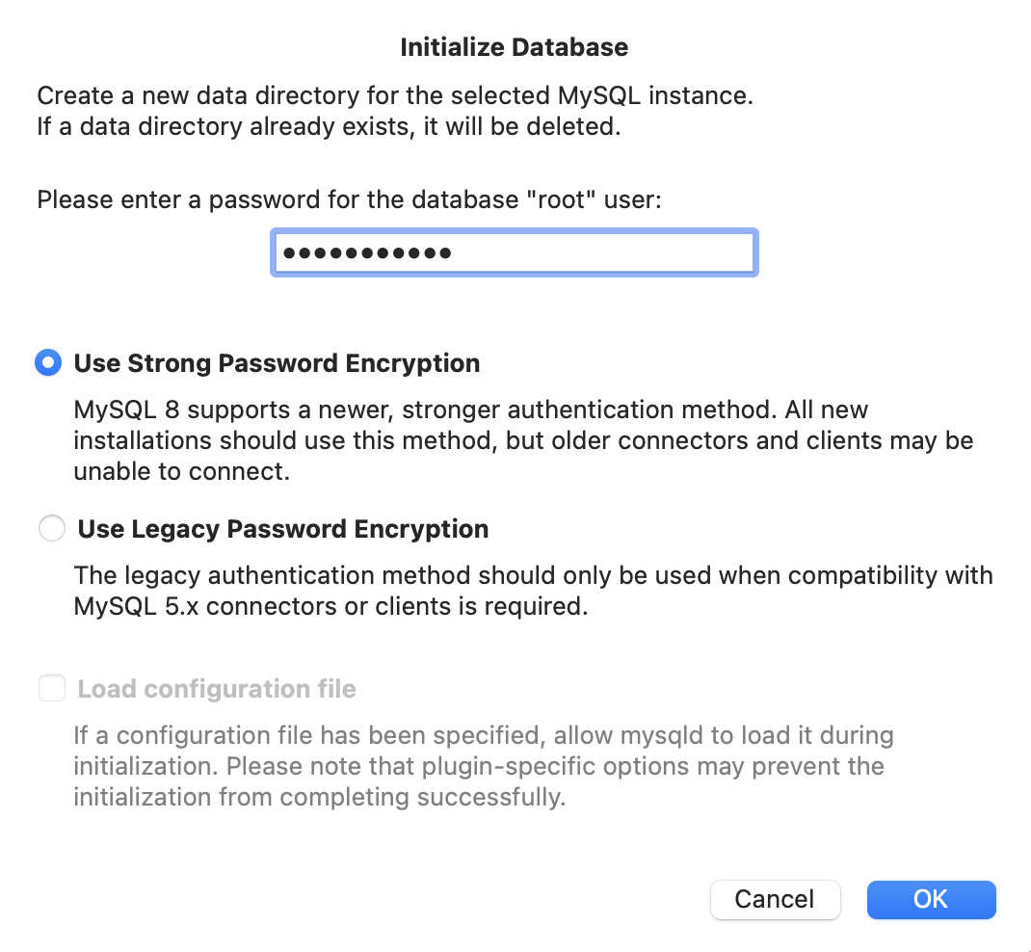

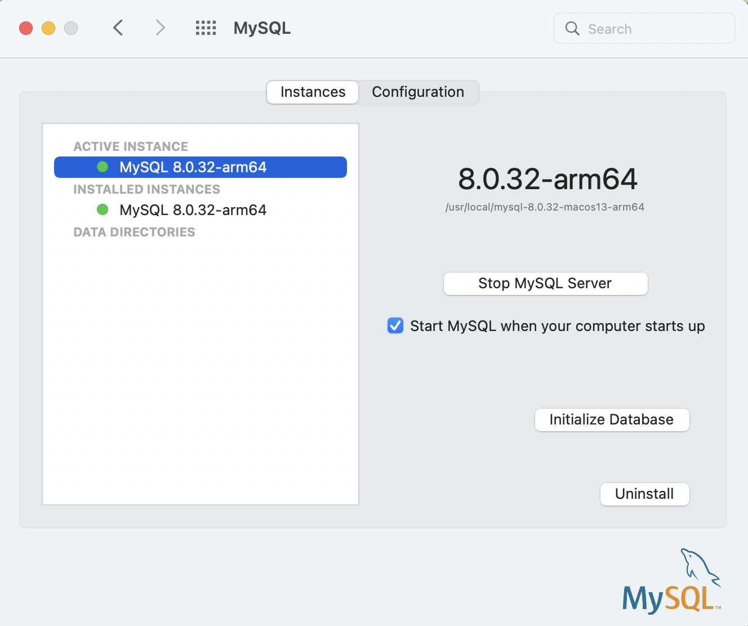

Run the following command on the Terminal:

/usr/local/mysql/bin/mysql -u root -p

Then enter the password

